**Stakeholder:** *Head of ESG at the World Trade Organization*

## **Executive Summary**

The rapid growth of the e-commerce industry, especially accelerated by the COVID-19 pandemic, has significantly increased carbon emissions, especially in last-mile1 logistics, which accounts for up to 50% of supply chain emissions. This segment is particularly challenging due to fragmented logistics networks, inefficient delivery systems, and urban congestion, all of which increase fuel consumption and emissions. The rise of small, frequent deliveries and the slow adoption of electric vehicles (EVs) further exacerbate the issue. Despite public commitments to sustainability, the industry's environmental impact remains high, with key contributors including transportation, warehousing, packaging waste, and returns. Addressing last-mile logistics through improved efficiency, cleaner technologies, and policy interventions is crucial to reducing the e-commerce sector's carbon footprint.

## **Background**

The e-commerce industry has experienced exponential growth, a trend further accelerated by the COVID-19 pandemic. According to Statista (2023), global e-commerce sales reached $5.7 trillion in 2022 and were projected to grow to $6.3 trillion by 2024. In 2023, approximately 356 billion packages were shipped globally, with projections reaching 498 billion by 2028 (World Trade Organization, 2023). This rapid growth has significantly increased energy consumption and carbon emissions across the supply chain, from manufacturing and packaging to warehousing and last-mile delivery.

The last-mile delivery segment poses a unique challenge as it is the most complex, time-consuming, and expensive step in the entire shipping process. It contributes up to 50% of total supply chain emissions. Despite corporate claims about green fleets and a transition to EVs, few companies fully implement sustainability initiatives. The complexity of fragmented logistics networks, the lack of standardized data collection among subcontractors, and the sheer volume of small individual deliveries make it difficult to obtain reliable publicly available data to address this problem.

We aim to explore possible policy interventions that could systematically limit the carbon footprint and environmental impact of this industry. To understand this segment, we first examine specific facets of the supply chain and assess the extent of the industry's emissions problem.

## **How pertinent of a problem has carbon emissions in the e-commerce industry been over the past few years?**

A study by the World Economic Forum (2020) estimates that e-commerce-related emissions could increase by 32% by 2030 if no mitigation strategies are implemented. The last-mile delivery segment is particularly problematic, accounting for up to 50% of total supply chain emissions (McKinsey & Company, 2020).

The Top Three Factors Contributing to Last-Mile Delivery Emissions

* Fragmented Logistics Networks: The reliance on multiple subcontractors and third-party logistics providers often leads to inefficiencies and redundant routes, increasing fuel consumption and emissions (World Trade Organization, 2023).
* Increased Delivery Frequency: The demand for same-day and next-day delivery has led to more frequent trips, often with partially filled vehicles, exacerbating emissions (International Transport Forum, 2024).
* Urban Congestion: Last-mile delivery often occurs in densely populated urban areas, where traffic congestion leads to longer idling times and higher emissions per delivery (European Environment Agency, 2022).

While many e-commerce companies have pledged to reduce their carbon footprints, implementation has been inconsistent. For instance, Amazon pledged to achieve net-zero carbon emissions by 2040 through its "Climate Pledge" (Amazon, 2023), yet the New Climate Institute (2022) found that Amazon's actual emissions reductions between 2019 and 2021 were only 2%.

Similarly, the adoption of EVs for last-mile delivery has been slower than expected. A study by the International Council on Clean Transportation (2022) found that EVs accounted for less than 1% of the global delivery fleet in 2022, despite their potential for significant emissions reductions. Barriers to adoption include high upfront costs, limited charging infrastructure, and the lack of standardized emissions data collection among subcontractors (World Trade Organization, 2023).

## **What are the most energy-intensive stages of the e-commerce supply chain and how do they contribute to the overall environmental impact?**

The e-commerce supply chain involves several stages, each with varying levels of energy consumption and environmental impact. According to research and industry reports the top four most energy-intensive stages are:

* **Transportation**

One of the largest sources of emissions in e-commerce is transportation, which includes the movement of goods from manufacturers to warehouses, between warehouses, and finally to customers. This stage involves substantial fuel consumption and emissions. Last-mile delivery remains the most energy- and carbon-intensive segment (Rai, 2021; Edwards & McKinnon, 2009). Fossil fuel-powered delivery fleets contribute significantly to CO₂ emissions (Kim & Kim, 2023). However, the adoption of alternative vehicles, such as EVs, has the potential to dramatically reduce emissions.

* **Warehousing and Storage**

Warehousing is a key component of the e-commerce supply chain, involving the storage of goods before transportation. These facilities consume a significant amount of energy due to lighting and air conditioning, and inefficiencies in space utilization and inventory management can further increase energy use. The trend toward larger, centralized warehouses to meet rising transportation demands has exacerbated energy consumption. Although warehouse buildings are becoming more energy-efficient, inefficiencies in order fulfillment and increased packaging requirements can offset these gains.

* **Product packaging**

Packaging occurs during the order picking and assembly phase, where items are sorted and packed for delivery to minimize damage during transport, returns, and re-deliveries. A study on the environmental impact of e-commerce in Korea found that e-commerce generated 4.8 times more packaging waste than traditional retail (Kim & Kim, 2022). Cardboard boxes, along with hard-to-recycle materials like printed return forms and sticky labels, contribute significantly to carbon emissions and landfill waste.

* **Returns**

Returns pose significant environmental challenges due to additional transportation emissions, repackaging waste, and energy-intensive processing. Returns require additional trips for collection, sorting, and redistribution, often leading to increased emissions. Returned items also need to be inspected, restocked, or refurbished, requiring additional energy for processing and storage. In many cases, returned products are not resold, resulting in further landfill waste.

Together, these stages highlight the complex and energy-intensive nature of the e-commerce supply chain. Different amounts of energy consumption and waste generation will result from a variety of factors, including the location of warehouses, the kind of packaging materials used, the effectiveness of transportation vehicles, and the volume of returns. Therefore, the environmental impact of the full e-commerce supply chain cannot be captured by a single number or one-size-fits-all approach.

## **How long does it currently take for a package to get delivered to the final consumer?**

Since actual travel distance data is unavailable, CO₂ emissions are estimated based on travel time. In our analysis of 50 regions in Shanghai, we found that approximately 14% of packages were delivered within 30 minutes, while 41% were completed within 60 minutes. The majority of deliveries fell within a range of 30 to 300 minutes.

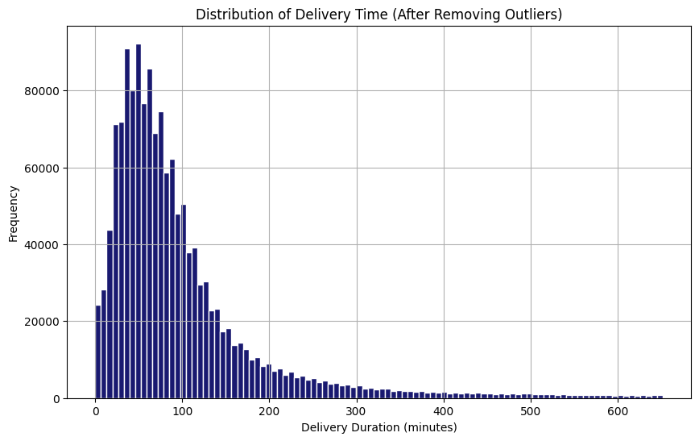

**Figure 1:** Histogram of last mile delivery duration across Shanghai.

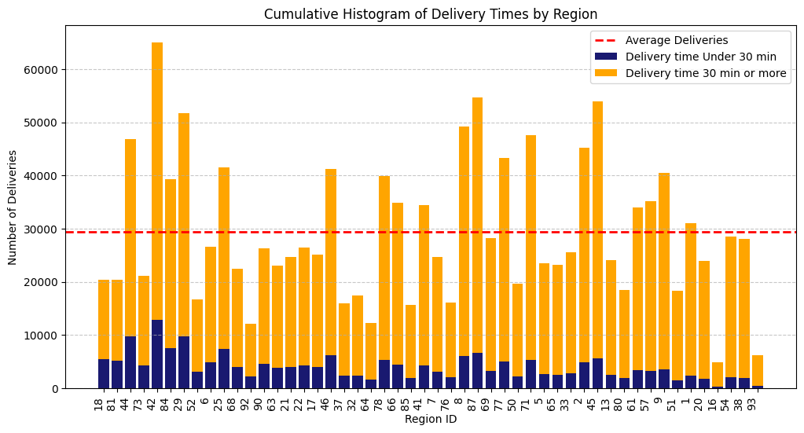

**Figure 2:** Total last mile deliveries across various regions in Shanghai (from our dataset) over a 6 month time period split into delivery times under vs over the 30 min benchmark.

Only four regions (18, 81, 44, and 73) crossing the benchmark had over 20% of the last mile deliveries completed within 30 minutes. Notably, among the four regions, Region 44 recorded approximately 47,000 deliveries—well above the regional average of 27,000. Although the Region Number itself does not provide geographical details, these regions are likely subdistricts with a reasonably fast-growing population size or central business district with high delivery demand.

## **Conclusion**

The rapid expansion of the e-commerce industry has undeniably contributed to increasing carbon emissions, with last-mile logistics emerging as a critical pain point. While efforts to mitigate the environmental impact of this sector exist, they remain fragmented and face substantial implementation barriers. Our analysis highlights key challenges, including logistics inefficiencies, high energy consumption across the supply chain, and continued reliance on fossil fuels. Despite ambitious sustainability pledges, progress has not been fast enough as desired.

Several limitations should be acknowledged in our assessment. Firstly, the lack of standardized and publicly available data on emissions from last-mile logistics presents a challenge in accurately quantifying the industry's impact. Some complex subcontracting system makes it worse. Additionally, while we focused on transportation, packaging, and returns, other factors—such as consumer behavior, regional regulations—also influence emissions. Currently available literature and industry reports also limit us from fully capturing the real-time shifts in supply chain practices.

Last-mile delivery inefficiencies are driven by structural and behavioral factors. Consumer expectations for fast and free shipping have intensified the frequency of deliveries, often leading to inefficient routing and increased emissions per package. Additionally, urban congestion exacerbates fuel consumption, making the transition to cleaner transportation modes even more pressing. Our findings also underscore that while electrification of delivery fleets is a promising solution, adoption remains hindered by cost barriers and infrastructure challenges. Finally, the role of packaging waste and returns cannot be overstated, as these processes contribute significantly to the overall carbon footprint of e-commerce operations.

Addressing sustainability challenges requires a collaborative approach, combining corporate responsibility, policy interventions, and consumer awareness. Companies must invest in alternative delivery models, such as micro-fulfillment centers and EV adoption. Regulatory measures, such as emissions limits and transparency mandates, could accelerate progress. Finally, consumer behavior shifts—such as choosing slower, consolidated shipping options—can collectively drive substantial reductions in emissions.

Ultimately, the sustainability of e-commerce hinges on collaborative efforts among governments, corporations, and consumers. While challenges remain, our analysis underscores the urgent need for systemic change to ensure that the industry can continue to thrive without compromising environmental responsibility.

## **Appendix**

The data used in this study was sourced from "LaDe: The First Comprehensive Last-mile Delivery Dataset from Industry." This study examines a sample of five cities in China (Shanghai, Hangzhou, Chongqing, Jilin, and Yantai), from which we selected Shanghai.

**Why did we look into delivery times?**

We observed that there exists a complex relationship between the delivery time, method and amount of carbon emissions in the last mile logistics sector. Faster delivery times, especially same-day services, often lead to increased emissions due to fragmented routes and more frequent trips. However, Shanghai has implemented innovative delivery methods to mitigate this impact. The use of electric bikes reduces emissions by about 70% compared to motorcycles, while metro-based underground logistics systems cut emissions by 28.3% versus traditional trucking. The city's adoption of electric vehicles for urban deliveries has shown a 30-40% reduction in emissions per kilometer compared to diesel trucks. These innovations demonstrate that while rapid delivery times can increase carbon footprint, strategic choices in delivery methods and technologies can significantly offset this effect.

**Why did we choose Shanghai?**

We chose Shanghai’s delivery data as a proxy for last-mile delivery behavior because, among the five cities in our dataset, it is not only the most representative in terms of delivery volume and city scale but also one of the major metro cities globally. In particular, Shanghai’s 26.3 million population and traffic congestion mirror issues in megacities like New York or Mumbai. Restrictions on trucks in urban cores and reliance on indirect delivery modes reflect strategies used globally to manage last-mile bottlenecks. High e-commerce penetration (28.6% of retail sales) has driven demand for faster, more flexible delivery options and makes Shanghai a valuable case for generalizability for further research.

**Data Processing**

We examined data from Shanghai, which includes 50 regions, aggregated over a six-month period from late 2022 to early 2023, totaling 1.4 million delivery orders to answer our research question.

We cleaned the data by only including the lower 99 percentile of the data to remove any skewness and outliers from the data. Although there were no null values, some extreme outliers were present, such as a maximum delivery time recorded at 47,739 minutes. It is reasonable to consider this as an abnormal value. We also included only regions with more than 10 observations available to ensure the completeness of the data we were working with. The % of total deliveries that happen under 30 minutes for each region has been aggregated and displayed in the graph below. Additionally, deliveries with a delivery time of less than 30 minutes were assumed to be short-distance trips.

However, this analysis only covers delivery orders processed through China's Cainiao platform. Delivery orders that did not go through this platform are difficult to verify. (1) Additionally, the dataset includes GPS data for package pick-up and delivery completion, but it does not contain information on the actual travel route or distance. Therefore, it is assumed that delivery time is proportional to delivery distance. (2) Furthermore, as the dataset does not specify the mode of transportation, it is difficult to determine which deliveries use internal combustion engine vehicles that generate CO₂ emissions.

The delivery counts across different Region IDs in Shanghai are relatively evenly distributed. Region 42, which has the highest number of deliveries, accounts for 4.4% of the total delivery volume.

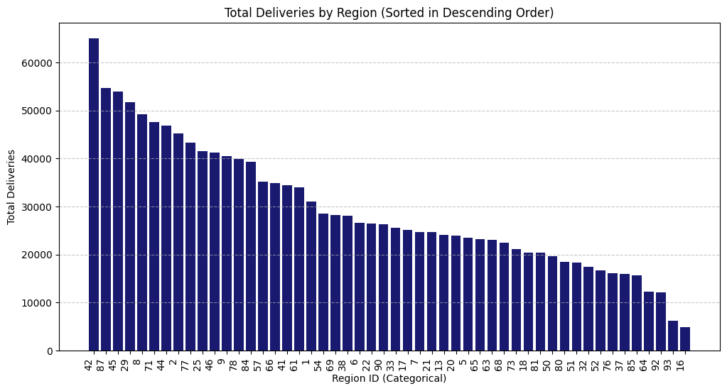

**Figure 3:** Total last mile deliveries across various regions in Shanghai (from our dataset) over a 6 month time period. On average, each region has approximately 29,600 deliveries.

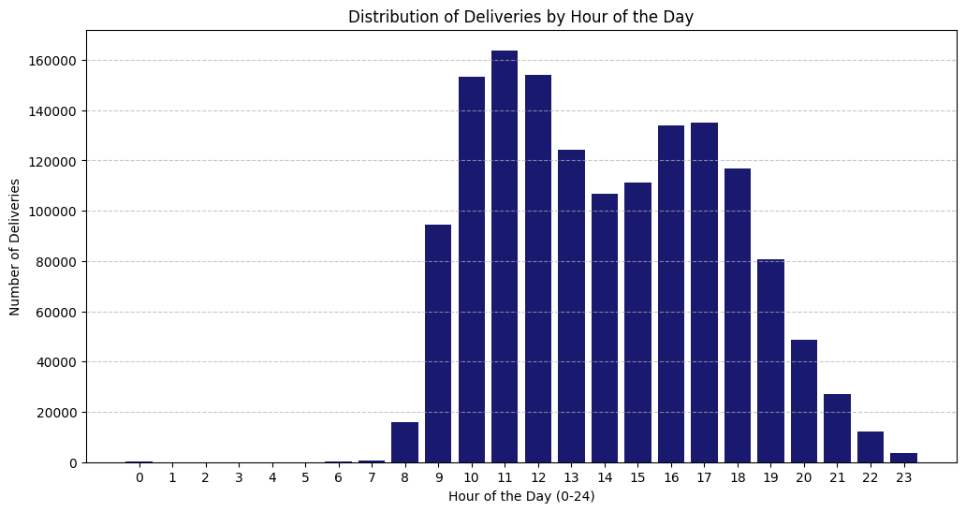

**Figure 4:** Last mile Delivery time distribution in Shanghai

## Most deliveries were actively completed between 10-11 AM, followed by another peak between 4-5 PM. Additionally, around 20% of deliveries were completed after 6 PM.

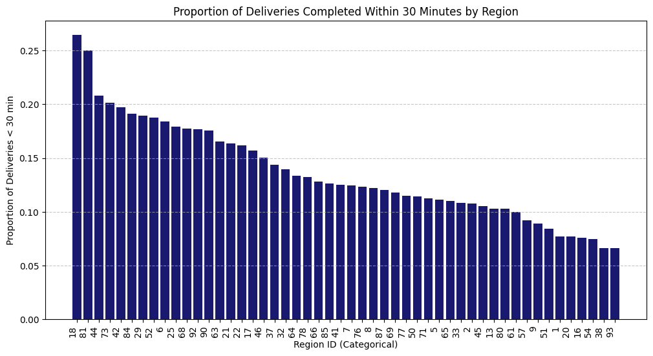

**Figure 5:** Proportion of last mile deliveries across various regions in Shanghai (from our dataset) over a 6 month time period completed under a 30 min benchmark.

## **References**

[1] Amazon. (2023). The Climate Pledge. Retrieved from <https://www.aboutamazon.com/planet/climate-pledge>

[2] Buldeo Rai, 2021; Edwards and McKinnon, (2009). Comparative analysis of the carbon footprints of conventional and online retailing: A “last mile” perspective <https://www.researchgate.net/publication/228901223_Comparative_analysis_of_the_carbon_footprints_of_conventional_and_online_retailing_A_last_mile_perspective>

[3]Deck Commerce (n.d.). *Sustainable fulfillment: How to reduce your carbon footprint.* <https://blog.deckcommerce.com/sustainable-fulfillment-how-to-reduce-your-carbon-footprint>

[4] European Environment Agency. (2022). Urban Mobility and Last-Mile Delivery. Retrieved from <https://www.eea.europa.eu/en/analysis/publications/transport-and-environment-report-2022>

[5] International Council on Clean Transportation (ICCT). (2022). Electric Vehicles in Last-Mile Delivery. Retrieved from <https://theicct.org/publication/tco-battery-diesel-delivery-trucks-jun2022/>

[6] International Transport Forum. (2024). The Impact of E-Commerce on Urban Logistics. Retrieved from <https://www.itf-oecd.org/final-frontier-urban-logistics>

[7] Kim, S., & Kim, N. (2022). Is online shopping packaging waste a threat to the environment? *Economics Letters*, 214, 110439. <https://www.researchgate.net/publication/359104168_Is_online_shopping_packaging_waste_a_threat_to_the_environment>

[8] LaDe: The First Comprehensive Last-mile Delivery Dataset from Industry. (2023). Retrieved from <https://arxiv.org/abs/2306.10675>

[9] McKinsey & Company. (2020). The Future of Last-Mile Delivery. Retrieved from <https://www.mckinsey.com/>

[10] New Climate Institute. (2022). Corporate Climate Responsibility Monitor. Retrieved from <https://newclimate.org/resources/publications/corporate-climate-responsibility-monitor-2022>

[11] Perboli, G., & Rosano, M. (2019). Parcel delivery in urban areas: Opportunities and threats for the mix of traditional and green business models. *Transportation Research Procedia*, 37, 391-398.

[12] Statista. (2023). Global E-Commerce Sales. Retrieved from <https://www.statista.com/>

[13] Sustainable Consumption and Production Journal (2017). *The environmental impact of e-commerce and strategies for sustainable practices.* *Journal of Cleaner Production* <https://www.sciencedirect.com/science/article/pii/S0959652617314117>

[14] United Nations Conference on Trade and Development (UNCTAD) (2024). *E-commerce and environmental sustainability.* Retrieved from

<https://unctad.org/system/files/official-document/der2024_ch05_en.pdf>

[15] World Economic Forum (WEF). (2020). The Future of the Last-Mile Ecosystem. Retrieved from <https://www.weforum.org/publications/the-future-of-the-last-mile-ecosystem/>